

Weather Station Project Progress

By: Alan O’Connell
Lecturer: Donal O’Donovan
Module: Interface Software Development
Date: 22/03/2026

I acknowledge, by submitting this report, that I am aware of the provisions in MTU’s Student Regulations which specifically cover cheating where any attempt is made to gain unfair advantage, whether in coursework, assessments or examinations.
I further acknowledge that I understand the Policy and associated Procedures together with the Supplementary Policy and Supplementary Procedure which have been approved for this period

1. Weekly project timeline
My project is a WPF app in C# that compares weather readings from two Met Eireann stations, Sherkin Island and Roches Point. I’m using Visual Studio and LiveCharts. Wpf 0.9.7 for the charting side of things. I split the work into seven weeks. Weeks 1 through 4 are done and I’ve started on Week 5.
Week | Activity | Status
1 | Project setup: created the WPF solution in Visual Studio, installed LiveCharts.Wpf 0.9.7 via NuGet. Built the XAML layout with two ListBoxes, station labels, parameter labels, menu bar with Load Stations, Plot Stations and Exit Application, and button panel. | Complete
2 | File I/O: Load Data scans both station folders and fills each ListBox. Time file excluded. Double-click handler stores the selected file path and updates the parameter label. | Complete
3 | Data extraction: parse the Time and parameter files into a SortedDictionary <DateTime, double> for both stations. Started wiring up the Plot button to LiveCharts. | Complete
4 | Plot button: both Sherkin and Roches Point series on a single CartesianChart with DateTime on the X-axis and the reading value on the Y-axis. | Complete
5 | Range feature: Slider bound to Count label (1 to max_element). Range button plots a subset on a second chart. | In Progress
6 | Differences file: per-timestamp difference written to a text file. | Outstanding
7 | Final testing, error handling (try/catch on all I/O), UI cleanup, stretch goals (if any). | Outstanding

2. Testing of completed components
So far, I have the UI layout, the Load Data handler, double-click parameter selection, file reading into a SortedDictionary <DateTime, double>, and the CartesianChart plot all working. I ran ten tests against these. Seven passes & three failures.
Test | Expected | Result
Click Load Data with both station folders present, each containing Temperature, Speed and Rainfall files. | Both ListBoxes populate. Time files are not shown. | Pass
Click Load Data when the SherkinWeatherData folder does not exist. | A MessageBox warning appears identifying the missing folder. | Pass
Double-click "Temperature" in ListBox 1 (Sherkin). | Parameter label beneath the Sherkin ListBox updates to show "Temperature". | Pass
Click Plot without first double-clicking a parameter in either ListBox. | A MessageBox prompts the user to select a parameter(s). | Pass
Double-click Temperature in both ListBoxes then click Plot. | Both station series appear on the Parameter Chart with time on the X-axis. | Pass
Click Plot after selecting a parameter. Check point count on chart matches number of lines in the data file. | Series point count matches the file line count. | Pass
Double-click Temperature in Sherkin only (no Roches selection), then click Plot. | A prompt should ask the user to select a Roches parameter before plotting. Instead, the app used the last selected Roches path with no warning. | Fail
Select Temperature in both ListBoxes, click Plot, then drag the Slider. | The Range Chart should update to show the number of readings matching the Slider position. | Fail
Select a parameter in both ListBoxes, delete one data file from disk, then click Plot. | A MessageBox identifying the missing file. Chart should not update. (Passes but needs more testing.) | Pass
Double-click Rainfall in the Sherkin ListBox and Temperature in the Roches ListBox, then click Plot. | A warning should appear or Plot should stay disabled until both stations have the same parameter. | Fail

Seven of the ten tests pass. Load Data fills both ListBoxes and leaves out the Time file. Double-clicking sets the parameter label, and EnablePlotIfReady keeps Plot disabled until both file paths are stored. Point counts on the chart matched the line counts in the data files.
I know about all three failures and I’m planning to fix them in Week 5. The first one is a stale file path bug. EnablePlotIfReady checks that both path strings are non-empty, but if I hit Load Data again after already selecting a Roches parameter, the old path hangs around. The guard passes when it shouldn’t, so the chart plots without a fresh selection. The fix is to clear both stored paths at the start of the Load Data handler.
The second failure is the slider. SldCount_ValueChanged is still not working, so dragging it does nothing and the Range Chart stays blank. The third is that I can pick Rainfall for Sherkin and Temperature for Roches and the app plots them on the same axis with no warning or labelling showing what each plot is currently representing. I need to compare both parameter name strings before calling ExtractData and show a MessageBox if they don’t match.

2.1 Screenshots
Below are three screenshots of the app in its current state. Figure 1 is the startup screen before any data is being loaded. Figure 2 shows a filtering bug where extra .txt files show up in the Sherkin ListBox. Figure 3 shows what happens when I pick Temperature for Sherkin and Rainfall for Roches and plot them together with no warning.
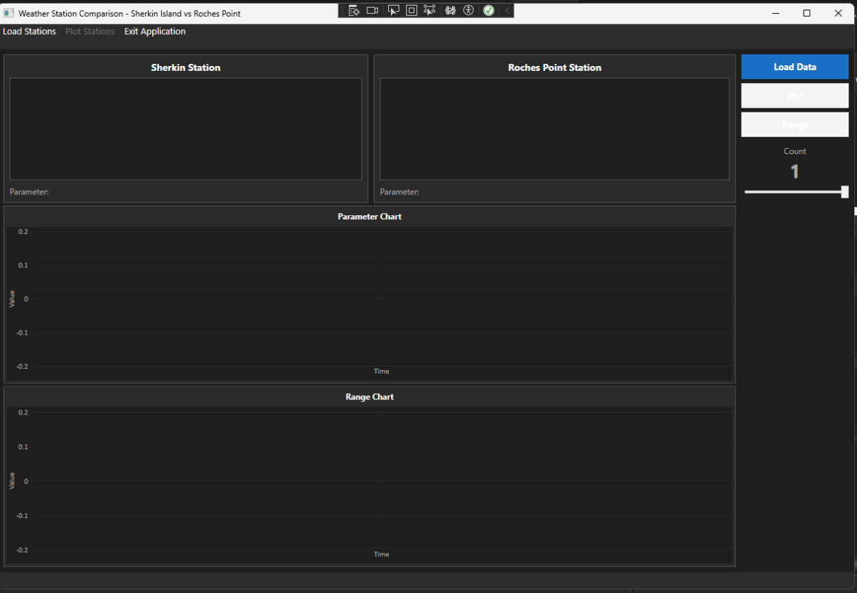
Figure 1: App on launch. Both ListBoxes empty, Plot and Range disabled.
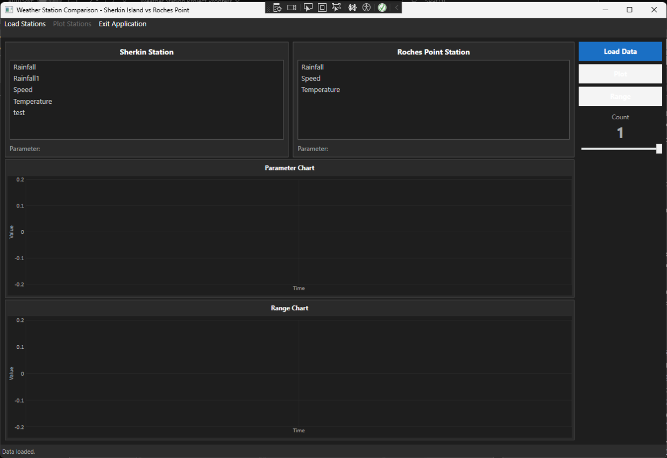
Figure 2: (Known bug) Sherkin ListBox shows extra entries. Directory scan picks up every .txt file.
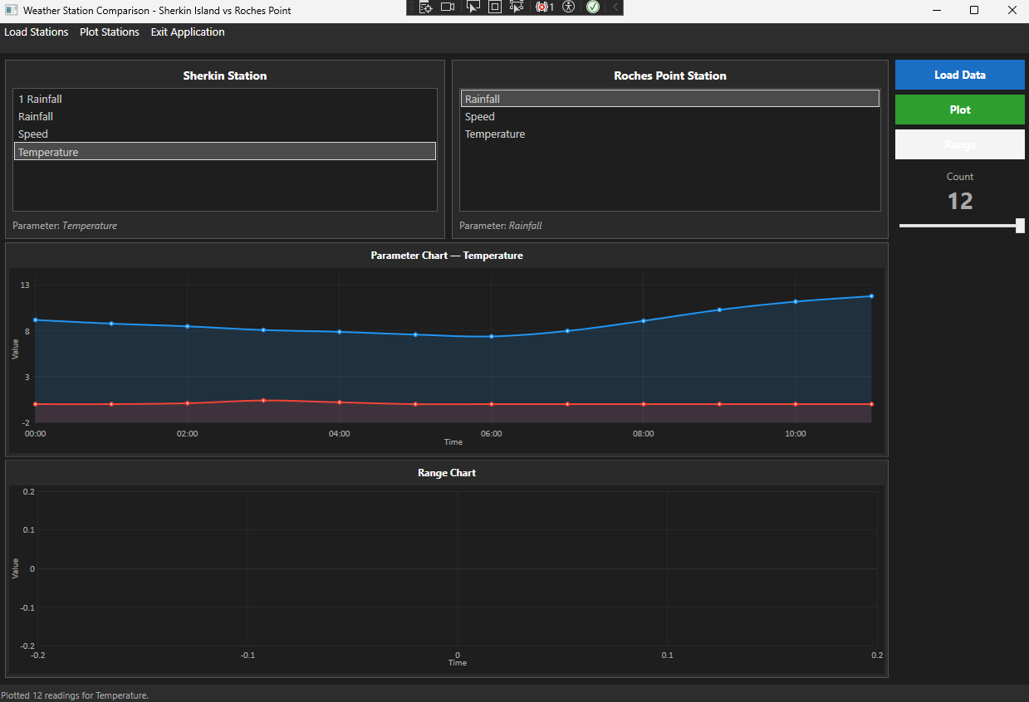
Figure 3: (Known bug) Mismatched parameters plotted without any warning.

3. Outstanding components and test plans

3.1 Range / Count / Slider
I'm binding a WPF Slider to a Count label, with a minimum of 1 and the maximum set to the number of entries in the SortedDictionary after plotting. SldCount_ValueChanged will update the Count label each time the slider moves. Clicking Range will take the first Count entries from the data using LINQ Take() and plot them on a second CartesianChart.
To test it I'll drag the slider to a few positions and check the point count on the chart matches the Count label. Count = 1 should give one data point and max should show the full dataset. I also need to check that clicking Range before loading data shows a MessageBox instead of crashing or giving an unexpected result.

3.2 Differences file
After plotting, the app will go through the DateTime keys that exist in both SortedDictionaries and subtract the Roches value from the Sherkin value for each one. I’ll write the results out to a .txt file using a StreamWriter. To test it I’ll open the output file and compare a few rows against the original data files to make sure the subtraction is correct.

3.3 Menu items and error handling
I need to wrap the file I/O in try-catch blocks, so the app shows a MessageBox instead of crashing or giving an unexpected result. if a file is missing or the data format is wrong. I’ll catch FileNotFoundException and FormatException separately and show the filename in the error message. To test it I’ll delete one of the data files from disk after loading and then click Plot to make sure the MessageBox appears and the app keeps running.

